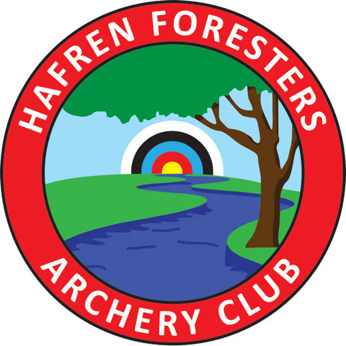 | Hafren Foresters Archery Club  Architectural Heritage Shoot  Kindly hosted by Long Mynd Archers

Tournament Date: Sunday 12th June 2022
Venue: New House Farm, Church Stretton, SY6 7JH
Judges: David Anslow
Name | Jo Sillitoe-Price | Closing date | Saturday 4th June
Telephone | 07736777037 | Shoot Type | Target – Outdoor
Address | 57 Tan-y-llan
 | Tregynon
 | Newtown | Entry Fees | Seniors - £6.00*
 | Powys |  | Juniors - £4.00*
 | SY16 3HA
Email | secretaryhfac@gmail.com

*£1 additional charge for any entries received after the closing date. Any archer entering will be expected to pay regardless of if they shoot or not. (This will be enforced).

Shooting / Awards:
Sighters at 1.00pm.

Please Note: As agreed by County, the following will apply. Archers meeting the criteria below must shoot the Long National.
- Lady recurve archer with a handicap of 50 = 436 National
- Gent recurve archer with a handicap of 44 = 500 National
- Lady compound with a handicap of 42 = 518 National
- Gent compound archer with a handicap of 37 = 555 National
Juniors wishing to shoot a higher round than their own (within the junior rounds) will still pay the junior fee but will compete against the age group they are shooting in for medals.
Juniors wishing to shoot in the senior rounds will pay the senior fee to do so and will be competing against the seniors for medals.
If an archer wishes to shoot in an age group that is lower than their own, they can do so, but will not be eligible for any medals.
Medals will be awarded over all categories depending on how many archers are shooting within that category, as follows:
Gold = awarded if there are 1-3 people shooting.
Silver = awarded if there are 4-6 people shooting.
Bronze = awarded if there are 7 or more people shooting.

.
Please ensure Junior Rounds are specified correctly when filling out the entry form, as there may not be room to move people around on the day

Rounds:
Round | Distance 1 | Distance 2
Long National Seniors | 80yds | 60yds
National 60 Seniors and Gents under 18 | 60yds | 50yds
National 50 Gents under 16 and Girls under 18 | 50yds | 40yds
National 40 Gents under 14 and Girls under 16 | 40yds | 30yds
National 30 Gents under 12 and Girls under 14 | 30yds | 20yds
National 20 Gents under 10 and Girls under 12 | 20yds | 10yds

48 Arrows shot at the longest distance and 24 arrows shot at the shorter distance.

Five zone scoring 9, 7, 5, 3, 1

Dress: ArcheryGB dress regulation rule 307 will apply.
Bow Styles: Recurve, Compound, Bare bow and Longbow
Please note:
All entrants must be members of an Archery GB or a W.A. associated organisation. Membership cards may be asked for at registration.
We will accept no liability for any loss or damage to any equipment during the Tournament for any reason.
Target list and results will be posted on the club website www.hafrenarchery.co.uk
Please send SAE if hard copy is required.
Please register with the organiser if you wish to take photographs or video.

Data Protection/Sharing:
When you enter competitions information may be collected and shared with tournament organisers, scoring systems and Archery GB.
The target list and results will be published on the website and emailed direct to clubs/individuals containing the archers name, club and where appropriate, county and region. For juniors their age category may also be included where appropriate.
Target lists and results will also be posted to clubs/individuals where a self-addressed envelope has been provided.
No information will be shared to any third party other than those stated above.
Hafren Foresters Architectural Heritage Shoot– Entry Form
Club:

Name | Senior or  Junior Category | Date of Birth Junior | AGB No. | Bow Style | Wheelchair /  Stool User | Round | Amount Paid | Parent / Guardians  Signature
 |  |  |  |  |  | Total
Cheques should be made payable to 'Hafren Foresters Archery Club'
BACS 54-10-40 04455223 Hafren Foresters. Please use archers name as reference.
DISABLED ARCHERS: Please state your needs:
Are you able to move on & off the line in the time allowed? Yes / No
Do you intend to bring an assistant/agent? Yes / No
ABLE BODIED ARCHERS:
Please tick if you are NOT prepared to collect and score arrows for disabled archers
Please tick if you do NOT want to appear in photographs
Email Address: |  | Contact Telephone

