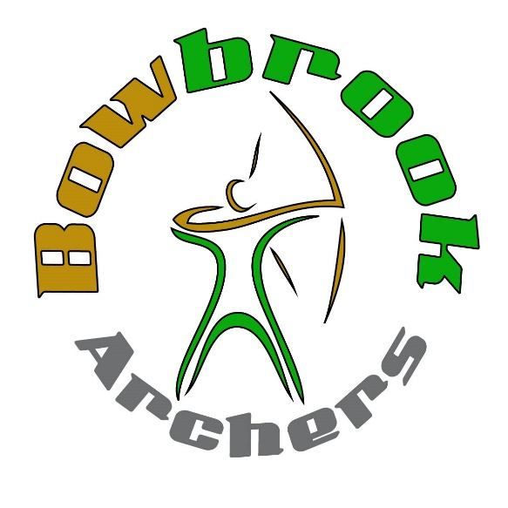
Date: 29th January 2022
Venue: Bowbrook Archers Indoor Range
Withington, SY4 4P5
Judge: Mr Robert Potts
Lady Paramount TBC
Round: UK Record status Single/Double WA18m
Fee. Single - £10 Double - £18
Places secured once payment received.
Sessions: A — Assembly 09:30, Sighters to follow
B — Assembly 13.30, Sighters to follow

Rules: | All ArcheryGB rules of Shooting will apply, including dress code and timing.
Targets: | All Compound/Recurve archers shoot on Triple spot faces  Barebow/Longbow will shoot on single 40cm face.
Medals: | Medals will be given out at end of the day.
Entries: | Closing date — 22 January 2022, unless full beforehand.  please submit all entries to:  joannerawlings72@gmail.com  Tel. 07815566935
Payment: | Reference: WA18m + surname"  Sort code: 77-27-10  Account: 34850960 Cheques payable to "Bowbrook Archers Ltd"
Target List: | The target list and any other information will be published on the Bowbrook Archers website and IANSEO one Week prior to the tournament.
Refreshments: | Hot & Cold refreshments will be available on the day
Photography: | Those who wish to take photographs at this event are to register with the tournament organiser on arrival. PARENTS AND GUARDIANS: please be aware that by entering your child you are also accepting that photographs may be taken at the event by authorised photographers. If you do not Wish photographs of you or your child to be used in this way, please enter N under 'photo's' on the Entry Form. Otherwise, you accept this situation, and you give permission for this to happen.
Data protection: | The following information may be collected and shared with tournament organisers, scoring systems and other competitors (for example, Target Lists and Results may be published):  First and Surnames, Gender, Bow Style, Date of Birth / Age category, Email, Address, telephone number, Club, County/Region, Round, Disabled Y/N, Disability info of necessary).
Disabled archers: | Should notify the organiser of the nature of their disability and any special requirements, e.g. use of wheelchair or stool for shooting and/or the need to remain on the shooting line. If you are visually impaired, do you need a spotter? The organisers Will do their best to accommodate you and meet your requirements.

Bowbrook Archers - WA18m Entry Form
Club

Name | Snr/Jnr | DOB  If Jnr | AGB no. | Bowstyle | Wheelchair/ Stool user | Session  Both | Fee | Parent/guardian Signature | No to Photo’s

Disabled Archers: Please state your needs .................................................................................................

Are you able to move on/off the line in the time allowed? ..........................................

Able Bodied Archers:
Please tick if you are NOT prepared to collect and score arrows for disabled archers.
Do you intend to bring an assistant? Y/N

Emergency  Tel. |  | Email:
Target List and Results will be put on the website and IANSEO closer to the event

Please email entries to: Joannerawlings72@gmail.com

